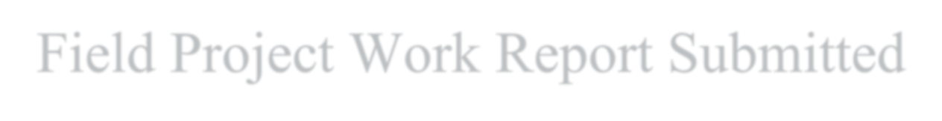
Field

Project Work Report Submitted

to

Sant Singaji Institute of Science and Management
Sandalpur [
Dewas]

Partial fulfillment of the Requirements for the Award of the Degree of
Bachelor of Computer Application (B.C.A) 3rd Year
(Session – 2025-26)


Project Title

Spotify Clone

By
Name - Payal Meena
Roll Number - 23134986

Under The supervision of
Mr./Ms - Yogendra Rajput

Address: NH 59-A,Gram-Sandalpur, Tehsil Khategaon, District Dewas, MP, India, 455336

1

ORGANIZATION / GOVT. DEPARTMENT CERTIFICATE
…………………………………………………………………………………………………………………

Office Address: …………………………………….. Contact no………………………………………., Email Address: - …………………………………………..

Date: -
TO WHOM IT MAY CONCERN

This is to certify that Ms. Radhika Tiwari , a student of Class BCA 3rd Year , Sant Singaji Institute of Science and Management,
Sandalpur has successfully completed the Project work in the field of Full Stack Project from 25/01/2026 to 09/02/2026 under the guidance of Mr. Yogendra Rajput at Sant Singaji Institute of Science And Management

During the period of her work with us, she was exposed to different processes and was found diligent, hardworking and inquisitive.
We wish her every success in life and career.

Place SSISM Organization Authorized Signature

Date…………..

DECLARATION

I hereby declare that this project report is based on the original work done by me, in which the use of published and unpublished material has been duly acknowledged.
I also declare that the submitted project report has not been submitted for any other degree or course previously or currently.

Student Name | Class | Roll Number | Sign (With date)
Radhika Tiwari | BCA 3rd Year | 23134990

Supervisor/ Director Approval Latter

SUPERVISOR / GUIDE CERTIFICATE

I, ________________________________, the undersigned, do hereby certify that the above-mentioned report is a genuine report of the Field Project work done by the student(s) under my direction.
It has been submitted after my approval to Sant Singaji Institute of Science and Management, Sandalpur.

Date: - …………………………………. Signature
Director/Supervisor
Place: - …………………………………

FEEDBACK FORM

NAME OF STUDENT: - Radhika Tiwari
NAME OF COLLEGE: - Sant Singaji Institute Of Science and Management
CLASS: - BCA 3rd Year
Roll NO.: - 23134990

S. NO. | EVALUATION BASIS | GIVEN GRADE  (A/B/C) | COMMENTS
1 | Student's Regular Attendance
2 | Theoretical Knowledge Acquired by the Student
3 | Skills Acquired by the Student in  Methodology Practical  Knowledge
4 | Students Interest in the Work/Seriousness
5 | Student's Attitude Towards  Learning in Procedure and  Behaviour
6 | Coordination With Co- Workers and Other members, Ability to Work in Group
7 | Student's Overall Grade

GRADE: - A-Excellent, B-Good, C-Normal
………………………………………………………………………… Signature Of the Authorised Person

Date: - …………………………………….. Name: - …………………………………….. Place: - …………………………………….. Seal: - ……………………………………..

ACKNOWLEDGEMENT

The work opportunity I had with …………………………………………………………
was a great chance for learning and professional development. Therefore, I consider myself very fortunate to have been provided with an opportunity to be a part of it.
The successful completion of any project requires the support and guidance of many individuals. I have taken help from different people for the preparation of this report, and I would like to express my deep gratitude to all of them.

I would like to express my special thanks of gratitude to my Supervisor Mr./Ms. ……………………………………………………for their mentorship and support throughout the project work. His/her guidance and supervision helped me to complete this work successfully.
I would also like to extend my gratitude to the Principal Sir “Mr. Prashant Sharma” for providing me with all the facility that was required.

Sincerely
Date: ………………………..
Name- ………………………..
Class- ………………………….
Roll No.- ……………………..

INDEX

S. No. | Name Of Topics | Page No.
1.
2.
3.
4.
5.
6.
7.
8.
9.
10.
11.
12.

